TIM Training Announcement

Rural Nevada TIM Train-the-Trainer Course
Why this is important… AAA Insurance reports that Responders are being struck and killed at traffic incidents in the U.S. ANNUAL average:
- 5 Firefighters
- 12 Law Enforcement Officers
- 52 Tow Truck Operators
- 276 Highway Workers
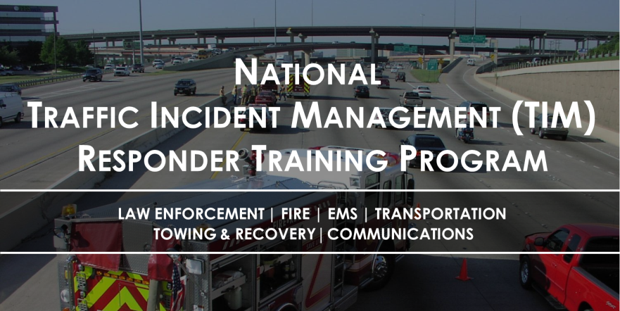

The Nevada TIM Training is built on the National TIM Responder Training Program, developed by responders for responders. It was designed to establish the foundation for and promote consistent training of all responders to achieve the three objectives of the TIM National Unified Goal (NUG):
- Responder Safety
- Safe, Quick Clearance
- Prompt, Reliable, Interoperable Communications
The Nevada Train-the-Trainer (TtT) course is intended to provide participants (i.e., trainers) the knowledge and materials necessary to conduct TIM training for TIM responders. The TtT is a 1½-day course that covers 8 hours of material, including classroom training as well as multiagency, multidiscipline hands-on outdoor activities and 4 hours of peer training. Trainers will have the flexibility to train others in the afternoon of the second day through use of the condensed 4-hour version of the training.
The target audience for this course is experienced trainers from all TIM disciplines, including: Law Enforcement, Fire/Rescue, Emergency Medical Service, Towing and Recovery, Emergency Management, Communications, and Highway/Transportation. Each TtT participant is expected to have both prior instructional and TIM experience.
Training is as follow:
Tues. September 19th - Day 1: 0800 to 1700 (8 hours)
Weds. September 20th - Day 2: 0800 – 1200 (4 hours) Peer training followed by a real time 4- hour training
Location: NHP Elko Training Room
Address: 3920 E. Idaho Street, Elko, NV
Registration - There are two separate steps for registering and both MUST be completed for State employees:
- Register with FHWA at Registration is located at: https://fhwatimtraining.wufoo.com/forms/national-tim-ttt-registration-elko-nv/[fhwatimtraining.wufoo.com]
- State employees can register for the class in NEATS. Non-state agencies please contact Jim Stewart, NHP jstewart@dps.state.nv.us, 775.753.1253, or Gary Sallee at gsallee@dot.state.nv.us

This training is being provided free of charge, however, agencies are responsible for all travel related expenses including lodging and meals. Hosted By: THE NEVADA TIM COALITION, NHP, and NDOT
If you have any questions regarding local TIM initiatives or your participation in this training, please contact Jim Stewart, 775.753.1253, JStewart@dps.state.nv.us or email Pat Gallagher at pat.gallagher@parsons.com
This training has also been endorsed by the International Association of Chiefs of Police (IACP), the International Association of Fire Chiefs (IAFC), the American Association of State Highway and Transportation Officials (AASHTO), the National Volunteer Fire Council (NVFC), the International Association of Directors of Law Enforcement Standards and Training (IADLEST), and the Towing and Recovery Association of America (TRAA).

