National Traffic Incident Management (TIM) Responder Training Program
Nevada TIM Responder Training Course Announcement

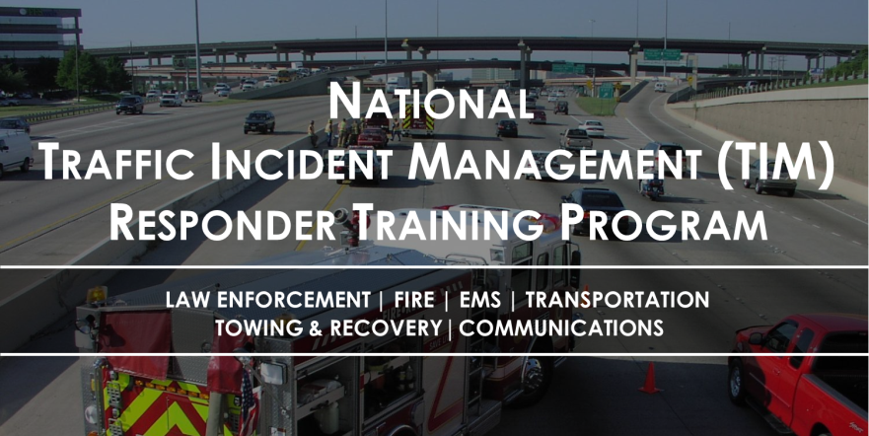
Rural Nevada 4 Hour TIM Training
Why this is important… AAA Insurance reports that Responders are being struck and killed at traffic incidents in the U.S. ANNUAL average:
- 5 Firefighters
- 12 Law Enforcement Officers
- 52 Tow Truck Operators
- 276 Highway Workers

The Nevada TIM Training is built on the National TIM Responder Training Program, developed by responders for responders. It was designed to establish the foundation for and promote consistent training of all responders to achieve the three objectives of the TIM National Unified Goal (NUG):
- Responder Safety
- Safe, Quick Clearance
- Prompt, Reliable, Interoperable Communications

The 4-Hour TIM course is intended to provide participating first responders the knowledge and materials necessary for clearing critical incidents as quickly as possible and reducing secondary crashes. Scene safety, communication, and relationship building will be emphasized in a multi-agency training approach with highly qualified instructors from multiple law enforcement agencies, fire agencies, NDOT, towing, and private sector emergency responders. The course structure will consist of 4 hours of training with credit for engineering and Post Law.

This training is being provided free of charge, however, agencies are responsible for all travel related expenses.
Details for the TIM Responder Training course are as follows:
Date: Wednesday September 20th
Time: 1:00 pm – 5:00 pm
Location: Nevada Highway Patrol Training Room - Elko
Address: 3920 E. Idaho Street, Elko, NV 89801, Elko, NV
To register for training: LINK
Pre-Requisite: Students are required to observe "Hats of Incident Command" by CFHD Training Videos, from the start up to the 13 minutes 42 seconds prior to attending the TIM training.
https://www.youtube.com/watch?v=AuxdAsf_eTQ&feature=youtu.be

Registration: DPS / NDOT Enroll through NEATS AND online at the registration link. This class is limited in size.

If you have any questions regarding local TIM initiatives or your participation in this training, please contact Major (retired) Pat Gallagher at pat.gallagher@parsons.com or (702)789-2028 or Trooper Jim Stewart. Please include your name, contact Info and Safety Summit reference.
This training has also been endorsed by the International Association of Chiefs of Police (IACP), the International Association of Fire Chiefs (IAFC), the American Association of State Highway and Transportation Officials (AASHTO), the National Volunteer Fire Council (NVFC), the International Association of Directors of Law Enforcement Standards and Training (IADLEST), and the Towing and Recovery Association of America (TRAA).

